**EXPERIMENT 2**

**Hafiz Ahmad 19L-1316**

# Cascading Style Sheets and JavaScript

**Objective**

* Introduction to CSS (Cascading Style sheets)
* Client side validation using JavaScript

**What is CSS?**

CSS stands for Cascading Style Sheets. Styles define how to display HTML elements and were added to HTML 4.0.

**Why we needed CSS?**

HTML was never intended to contain tags for formatting a document.HTML was intended to define the content of a document, like:

<h1>This is a heading</h1>

<p>This is a paragraph.</p>

When tags like <font>, and color attributes were added to the HTML 3.2 specification, it started a nightmare for web developers. Development of large web sites, where fonts and color information were added to every single page, became a long and expensive process.

To solve this problem, the World Wide Web Consortium (W3C) created CSS. CSS defines HOW HTML elements are to be displayed. Styles are normally saved in external .css files. External style sheets enable you to change the appearance and layout of all the pages in a Web site, just by editing one single file!

**CSS Syntax**

A CSS rule has two main parts: a selector, and one or more declarations as shown in Figure 1:

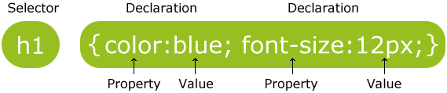

**Figure 1**

The selector is normally the HTML element you want to style.

Each declaration consists of a property and a value.

The property is the style attribute you want to change. Each property has a value.

In addition to setting a style for a HTML element, CSS allows you to specify your own selectors called "id" and "class".

***Id Selector Syntax***  
The id selector is used to specify a style for a single, unique element.  
The id selector uses the id attribute of the HTML element, and is defined with a "#".  
The style rule below will be applied to the element with id="para1":

#para1  
{  
text-align:center;  
color:red;  
}

***Class Selector Syntax***The class selector is used to specify a style for a group of elements. Unlike the id selector, the class selector is most often used on several elements.   
This allows you to set a particular style for many HTML elements with the same class. The class selector uses the HTML class attribute, and is defined with a "."  
In the example below, all HTML elements with class="center" will be center-aligned:

.center {text-align:center;}

**How to apply CSS**

There are three ways of inserting a style sheet:

* External style sheet
* Internal style sheet
* Inline style

***External Style sheet***An external style sheet is ideal when the style is applied to many pages. With an external style sheet, you can change the look of an entire Web site by changing one file. Each page must link to the style sheet using the <link> tag. The <link> tag goes inside the head section:

<head>  
<link rel="stylesheet" type="text/css" href="mystyle.css"/>  
</head>  
  
An external style sheet can be written in any text editor. The file should not contain any html tags. Your style sheet should be saved with a .css extension. An example of a style sheet file is shown below:  
  
hr {color:sienna;}  
p {margin-left:20px;}  
body {background-image:url("images/back40.gif");}

***Internal Style sheet***An internal style sheet should be used when a single document has a unique style. You define internal styles in the head section of an HTML page, by using the <style> tag, like this:

<head>  
<style>  
hr {color:sienna;}  
p {margin-left:20px;}  
body {background-image:url("images/back40.gif");}  
</style>  
</head>

***Inline Style sheet***

An inline style loses many of the advantages of style sheets by mixing content with presentation. Use this method sparingly!

To use inline styles you use the style attribute in the relevant tag. The style attribute can contain any CSS property. The example shows how to change the color and the left margin of a paragraph:

<p style="color:sienna;margin-left:20px">This is a paragraph.</p>

## Exercise 1: Please run the lab2.html file lying in your lab folder and paste a screenshot in the space below.

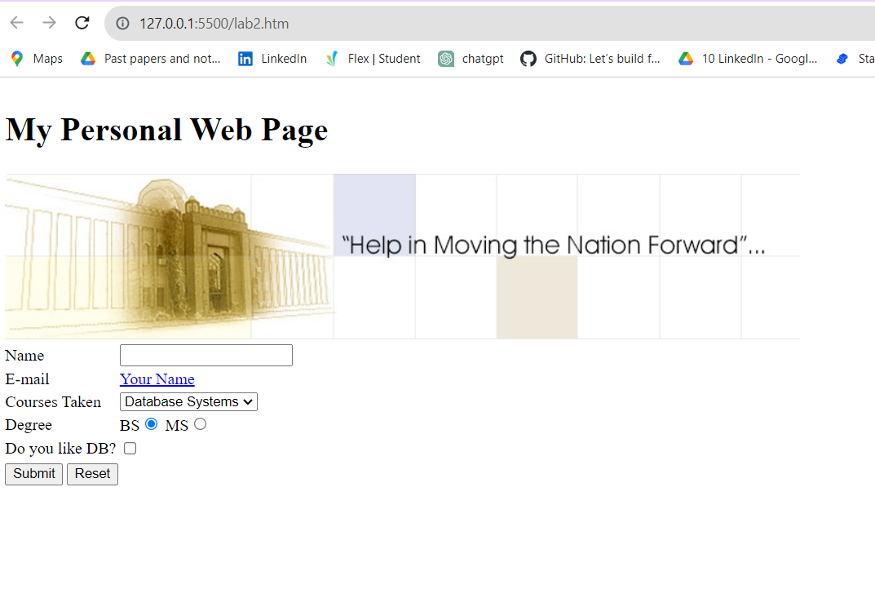

## Now apply the style sheet file (style.css) lying in the lab folder as an external style sheet and paste the screenshot of the output in the space below.

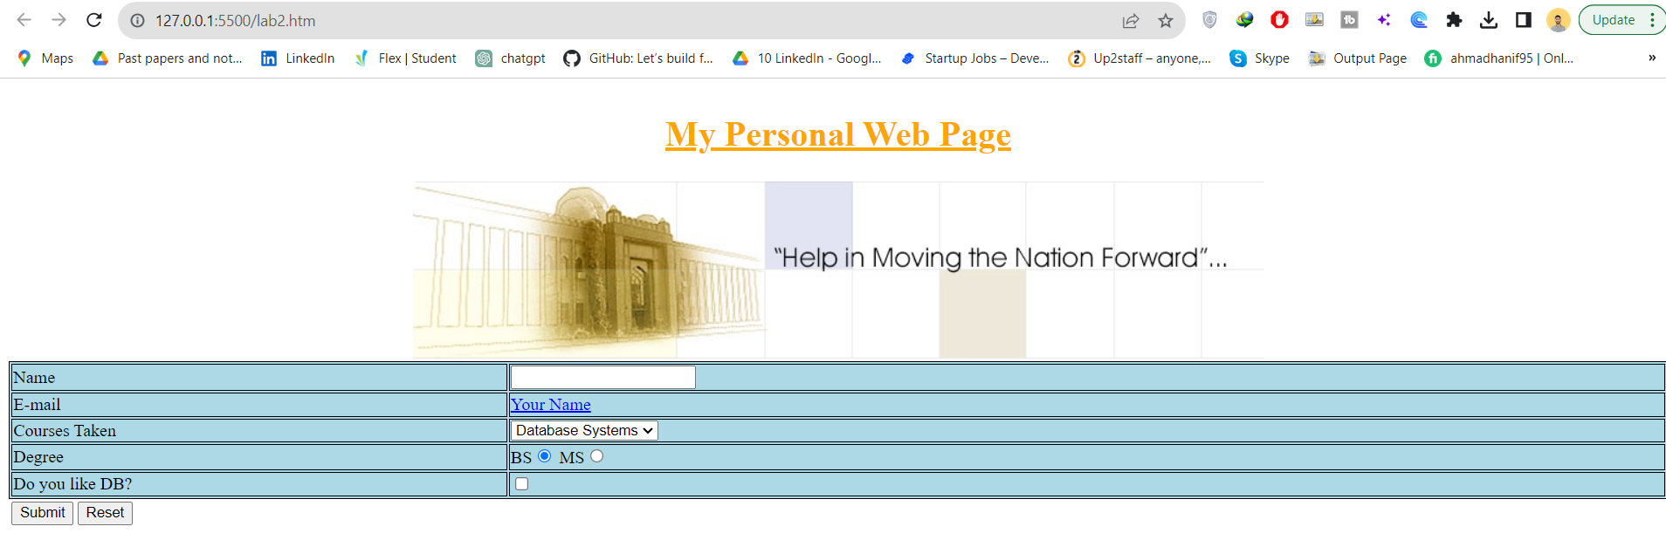

Make changes in the stylesheet file so the last table with id=bottom also becomes centre aligned as the above two tables. Paste the code you added to the style sheet file in the space below

#bottom

{

    text-align:center;

    margin-left:auto;

    margin-right:auto;

    width:100%;

}

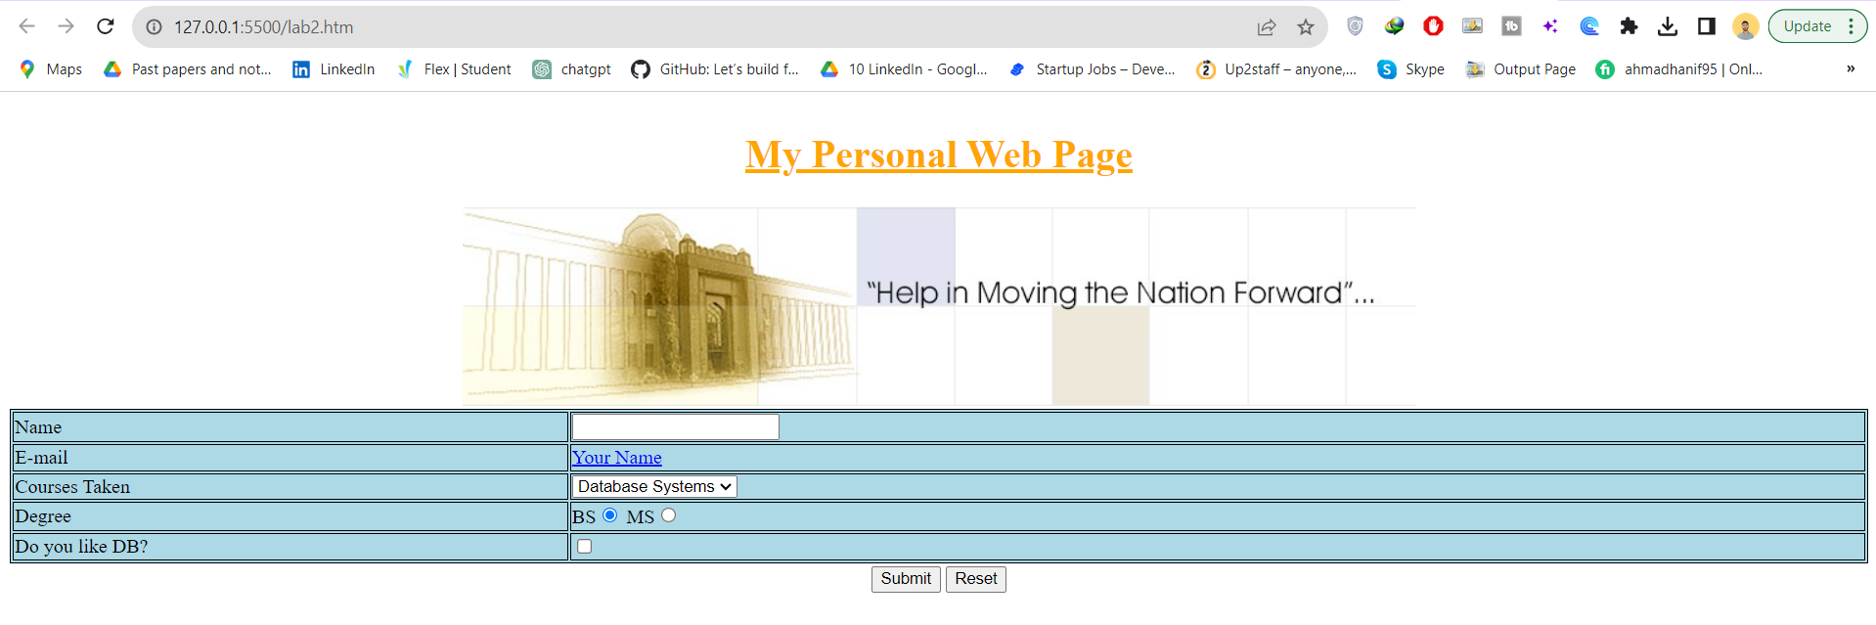

**What is JavaScript?**

* A scripting language is a lightweight programming language.
* JavaScript is programming code that can be inserted into HTML pages.
* JavaScript inserted into HTML pages, can be executed by all modern web browsers.

**Usage of JavaScript**

* Writing Into HTML Output  
  document.write("<h1>This is a heading</h1>");
* Reacting to Events  
  <button type="button" onclick="alert('Welcome!')">Click Me!</button>
* Changing HTML Content  
  x=document.getElementById("demo")  //Find the element

x.innerHTML="Testing… “;

* Changing HTML Styles

x=document.getElementById("demo")  //Find the element   
x.style.color="#ff0000";           //Change the style

* Validate Input

var num=document.getElementById("demo") .value //demo is a textbox  
if (num==null || num==””)  
 {alert("Enter a value please")};

**How to apply JavaScript**

To insert a JavaScript into an HTML page, use the <script> tag.  
The <script> and </script> tells where the JavaScript starts and ends.

There are two ways of inserting JavaScript:

* 1. Internal JavaScript
  2. External JavaScript

**Internal JavaScript**

You can place an unlimited number of scripts in an HTML document.  
Scripts can be in the <body> or in the <head> section of HTML, and/or in both.  
It is a common practice to put functions in the <head> section, or at the bottom of the page. This way they are all in one place and do not interfere with page content.

<!DOCTYPE html>  
<html>

<head>  
<script language="javascript">  
function myFunction()  
{  
document.getElementById("demo").innerHTML="My First JavaScript Function";  
}  
</script>  
</head>

<body>

<h1>My Web Page</h1>

<p id="demo">A Paragraph</p>

<button type="button" onclick="myFunction()">Try it</button>

</body>  
</html>

**External JavaScript**

Scripts can also be placed in external files. External files often contain code to be used by several different web pages.   
External JavaScript files have the file extension .js.

To use an external script, point to the .js file in the "src" attribute of the <script> tag:

<!DOCTYPE html>  
<html>  
<body>  
<script src="myScript.js" language="javascript"></script>  
</body>  
</html>

## Exercise 2: Practice JavaScript

Please add the myScript.js file as an external javascript file to your lab2.html page. To the submit and reset buttons add the onclick event so that “validate” function is called upon clicking Submit and reset function is called on clicking Reset button. Please paste your changes in the space below as well as screenshot of what happens after clicking Submit.

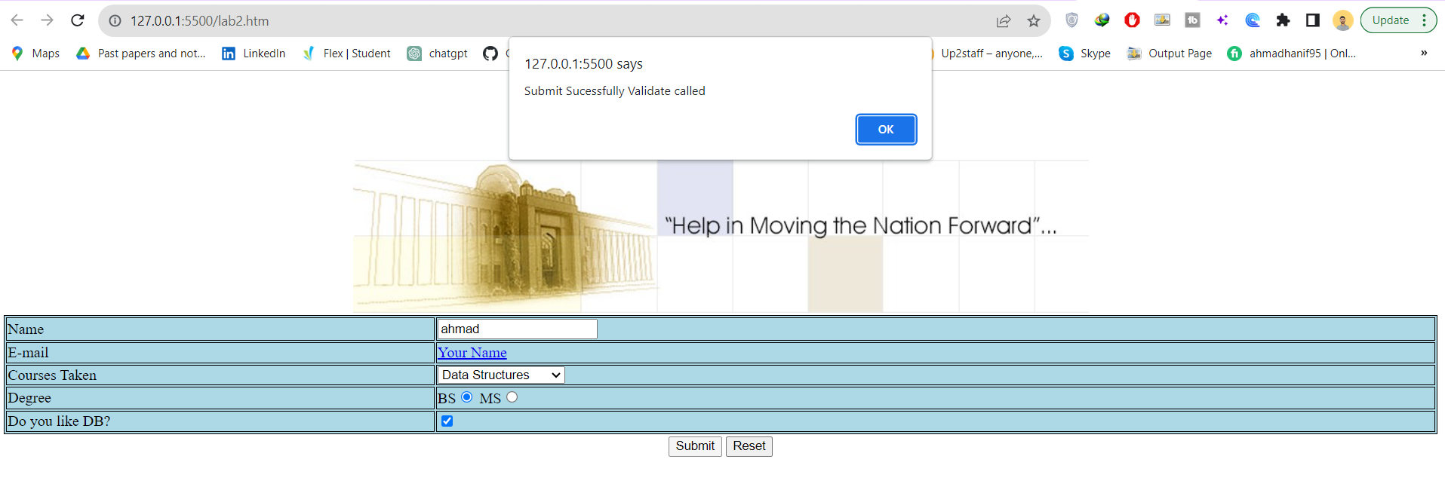

When I enter no data 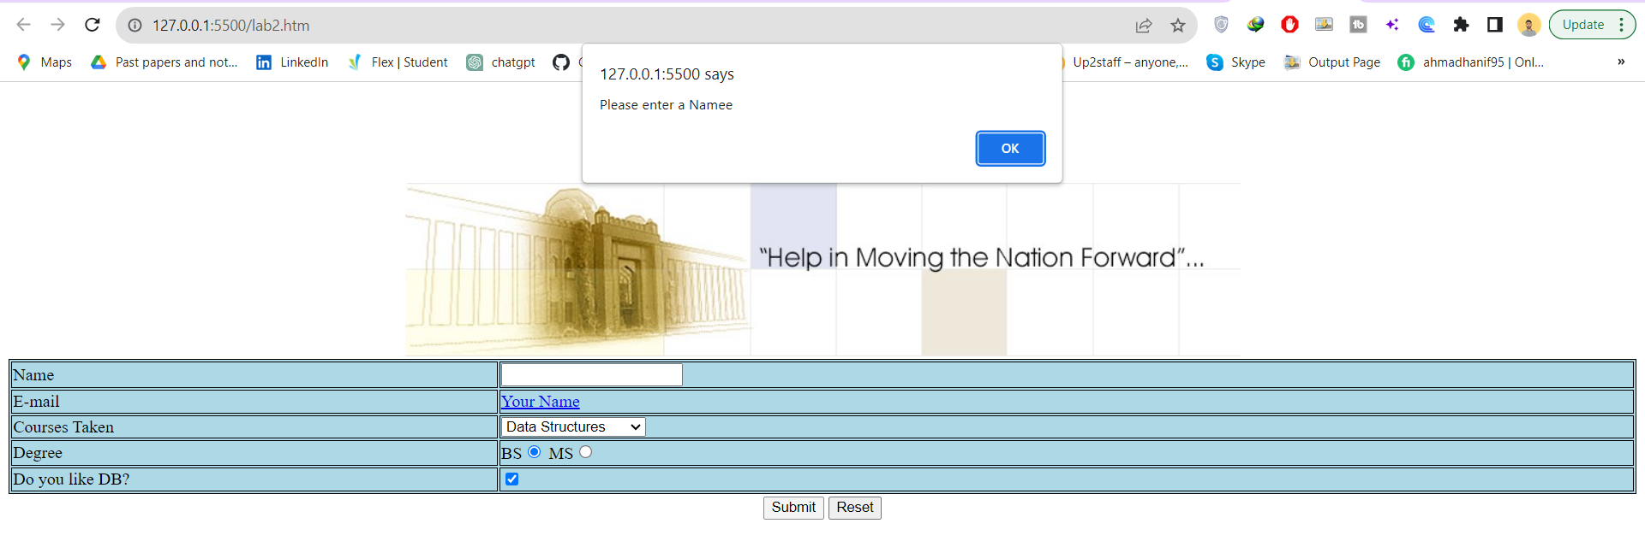

After clicking ok colour is change due to java script statement condition if enter information is null or empty then color is going to be null.

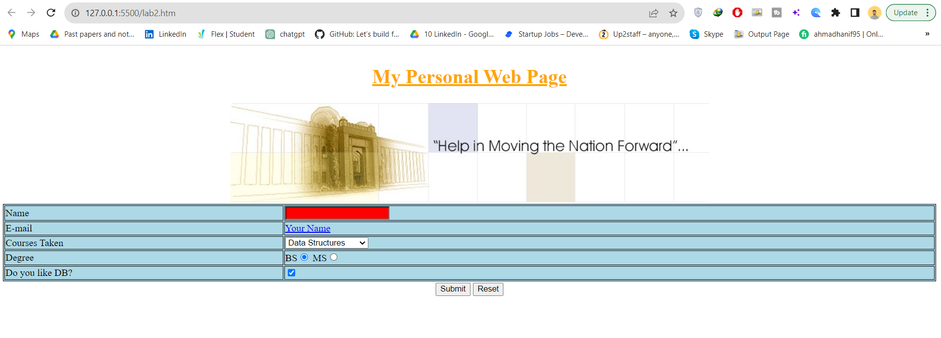

If I call reset then 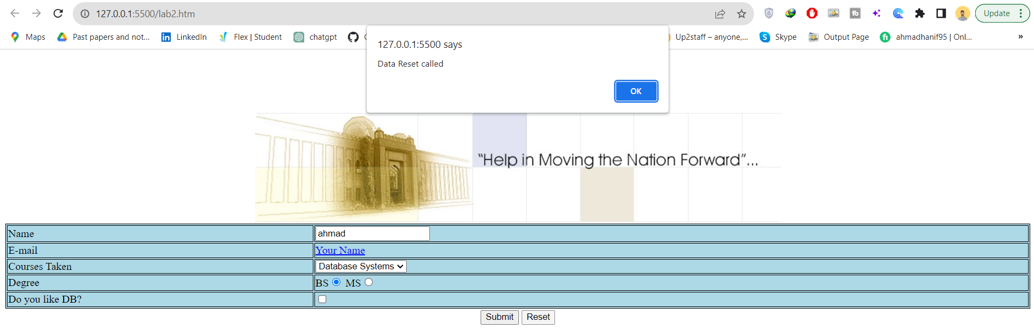

After clicking data reset okhy then output is :

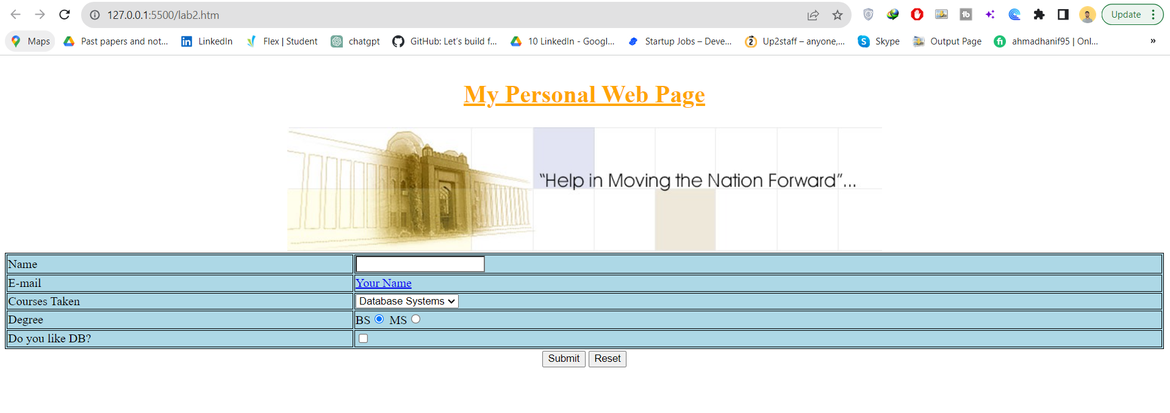

## Exercise 3: Practice JavaScript

Please write a HTML page which looks like figure2 below. After that write a JavaScript function to convert Celsius into Fahrenheit and vice versa in HTML using JavaScript on input controls.

If both the textboxes are empty on clicking either button give an error message on the screen otherwise do the conversion and show the output value in the relevant field.

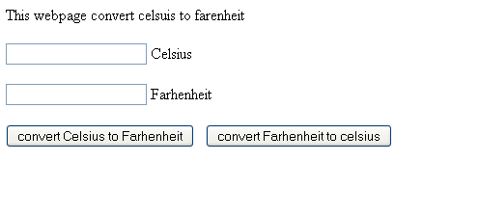

**Figure 2**

Please give your HTML as well as javascript code for doing the above exercise in the space below:

<!DOCTYPE >

<html>

  <head>

    <title>Temperature Conversion Scaler</title>

    <link rel="stylesheet" type="text/css" href="style.css" />

  </head>

  <body>

    <h5>This website converts celsisu to farenheit</h5>

    <table>

      <tr>

        <th><input id="cen" /></th>

        <td>Celsius</td>

      </tr>

      <tr>

        <th><input id="far" /></th>

        <td>Fareheight</td>

      </tr>

      <tr>

        <th><button onclick="fun1()" >convert Celsius to Farhenheit</button></th>

        <td><button onclick="fun2()" >convert Farhenheit to celsius</button></td>

      </tr>

    </table>

  </body>

  <script type="text/javascript" src="script.js"></script>

</html>

Java Script Code

function fun1()

{

    var dom1= document.getElementById('cen');

    var dom2= document.getElementById('far');

    var val1 = ((dom1.value *9 / 5 )+ 32);

   dom2.value =val1;

}

function fun2() {

    var dom1= document.getElementById('far');

    var dom2= document.getElementById('cen');

    var val1 = ((dom1.value - 32) * (5/9));

   dom2.value =val1;

}

